**Bug Report**

|  |  |
| --- | --- |
| Defect ID |  |
| Build Name | Product Display_ac |
| Build ID | B05 |
| Release Name | Release2 |
| Module Name | Product Display |
| URL | <https://demo.opencart.com> |
| Test Case Name | Opencart_Product Display |
| Test Data | Product Name: iphone |
| Found By | Priyanka |
| Test Environment | OS- Windows 10  Browser- Chrome |
| Status | New |
| Severity | Minor |
| Priority | Low |
| Assigned to | Dev lead |

**Description**

The negative quantity or zero quantity or null quantity should not be allowed in the Product Display Page

**Steps to reproduce**

1. Enter any existing Product name into the Search text box field, which has no minimum quanitity set - <Refer Test Data>

2. Click on the button having search icon  
3. Click on the Product displayed in the Search results  
4. Check the Qty text field in the Product Display Page  
5. Update the quantity in the Qty text field by providing a negative number or zero number or null quanitity and click on 'Add to Cart' button

**Expected result**

A field level message - 'Quantity should be a positive number' or 'Quantity cannot be zero, null or negative' should be displayed under the Qty text field

**Actual result**

Success: You have added iMac to your Shopping cart message should display

**Screen Shot**

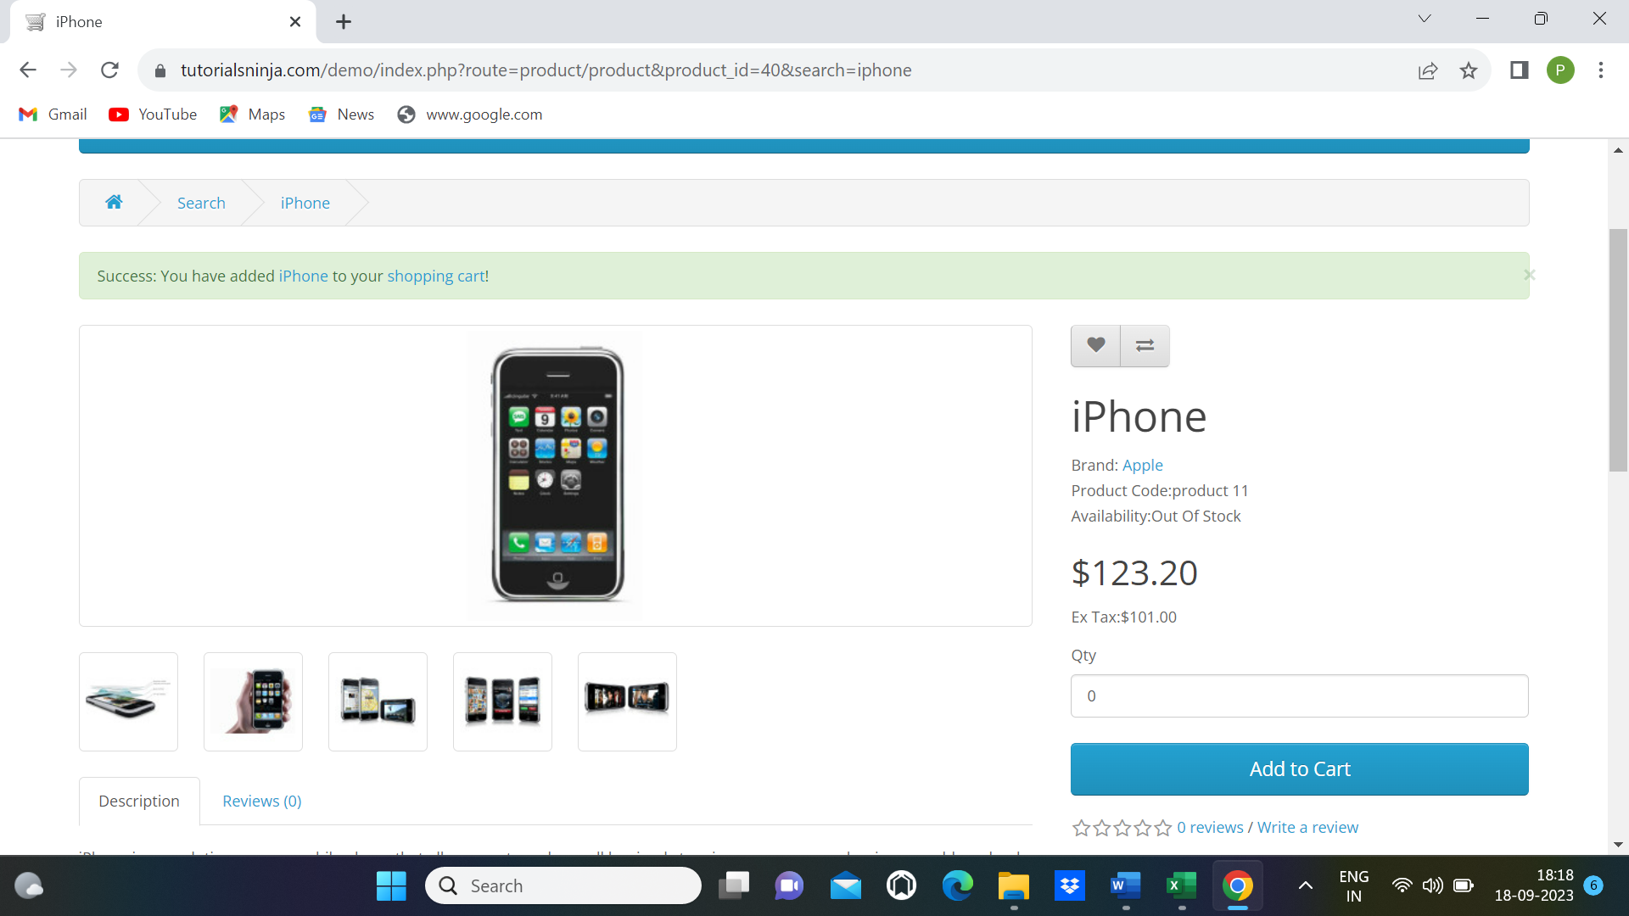

|  |  |  |
| --- | --- | --- |
| Submit | Clear | Cancel |